STACK MANAGEMENT INVENTORY

Keep track of Inventory

1. INTRODUCTION

* Stack management
* Team ID: NM2025TMID3957
* Team Leader: Santhosh L & [lsanthosh865@gmail.com](mailto:lsanthosh865@gmail.com)
* Team Members
* Sarvesh SP & [Sarvesh1152007@gmail.com](mailto:Sarvesh1152007@gmail.com)
* Mohammed Aareef M [&aareefmohammed@gmail.com](mailto:&aareefmohammed@gmail.com)
* Mohamed Ali I & [aliraiman1328@gmail.com](mailto:aliraiman1328@gmail.com)

1. PROJECT OVERVIEW

* Purpose : To provide a comprehensive overview based on the assumption that you are asking about a stock management inventory website
* Features:
* Real-time stock tracking
* Multi – location management
* Barcode/QR code scanning
* Lot and serial Number

1. ARCHITECTURE

* Frontend: React.js with Bootstrap and and material
* Backend: Node.js and Express.js manging server logic and API endpoint
* Database: MongoDB stores user data, project information ,applications, and chat messages

4. Setup Instructions

• Prerequisites:

– Node.js

– MongoDB

2

– Git

– React.js

– Express.js – Mongoose – Visual Studio Code

• Installation Steps:

# Clone the repository git clone

# Install client dependencies cd

client npm install

# Install server dependencies cd

../server npm install

5. Folder Structure

SB-Works/

|-- client/ # React frontend

|__components/

L__ pages/

|__ server/ # Node.js backend

|__routes/

|__ models/

|__ controllers/

6. Running the Application

• Frontend:

cd client

npm start •

Backend:

cd server npm

start

• Access: Visit http://localhost:3000

7. API Documentation

• User:

– /api/user/register

– /api/user/login

• Projects:

3

– /api/projects/create

– /api/projects/:id • Applications: /api/apply

• Chats:

– /api/chat/send

– /api/chat/:userId

8. Authentication

• JWT-based authentication for secure login

• Middleware protects private routes

9. User Interface

• Landing Page

• Freelancer Dashboard

• Admin Panel

• Project Details Page

10. Testing

• Manual testing during milestones

• Tools: Postman, Chrome Dev Tools

11. Screenshots or Demo

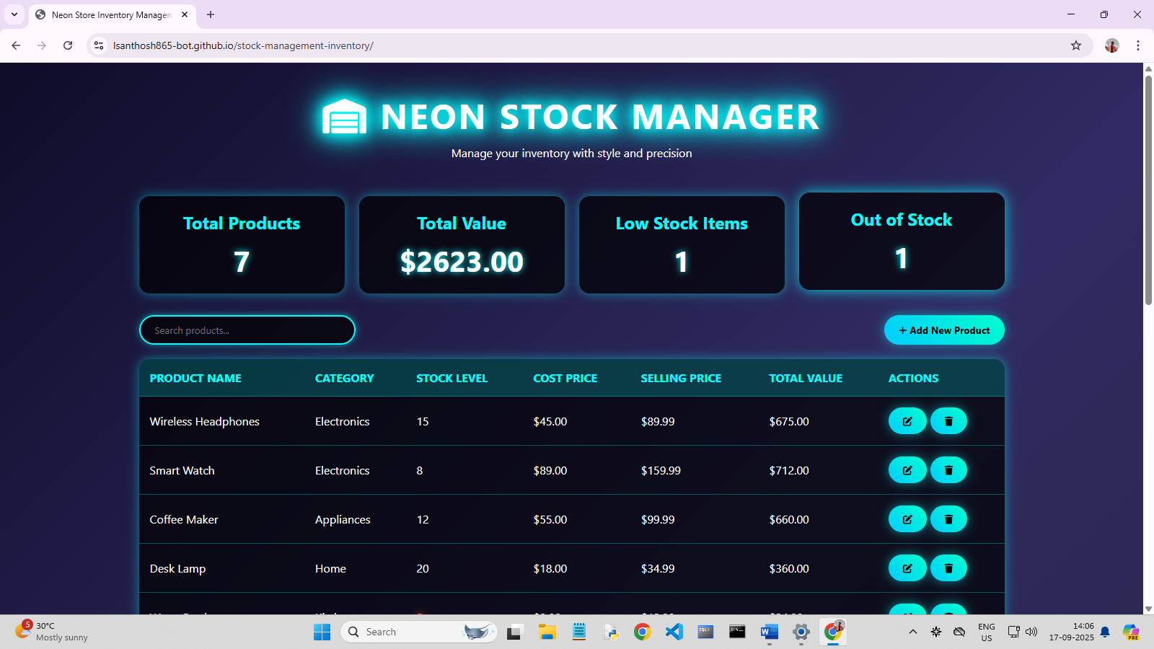

12. Known Issues:

- may be some error happen while clicking an stack products

13. Future Enhancements:

* Code Generation
* Automated debugging and testing
* Personalization
* Progressive web application